**CS31006: Computer Networks**

**Spring 2017: Mid-Semester Examination**

**SOLUTIONS**

**Question 1**

Select the most appropriate option (only one) for the following questions: [1x10 = 10]

1. What is the frequency of the DC component in a signal?
2. 0 (b) Between 400 – 4000 Hz
3. Between 20 Hz – 20 kHz (d) Infinite

**Answer**: (a) 0

Frequency of DC component is zero.

1. Which of the following constitutes a node in a computer network?
2. A device where data originates (b) A device which routes data
3. A device where data terminates (d) All of the above

**Answer**: (d) All of the above

Devices where data originate and terminate are the end-devices (PC, smartphone, etc.), and devices which route data are routers, switches, etc. They are all nodes in a computer network.

1. In the layer hierarchy as the data packet moves from the upper to the lower layers, headers are:
2. Added (b) Removed
3. Rearranged (d) Modified

**Answer**: (a) Added

Existing headers are not modified in any way, only new layers corresponding to the lower layers are added.

1. The number of layers in the OSI model and the TCP/IP model are, respectively:
2. 6, 5 (b) 7, 4
3. 7, 6 (d) 7, 5

**Answer**: (b) 7, 4

The OSI model has 7 layers, whereas, the TCP/IP model has 4 layers.

1. Communication between a computer and a keyboard involves what type of transmission?
2. Half-duplex (b) Full-duplex
3. Simplex (d) None of the above

**Answer**: (c) Simplex

Data flows in single direction, i.e., from the keyboard to the computer.

1. The role of a “gateway” is to connect:
2. A router to a switch (b) A PC to another PC
3. A router to an end-device (d) A network to another network

**Answer**: (d) A network to another network

The role of a gateway is to connect one network to another.

1. Which of the following services belong in the “deep” web?
2. Profiles on Twitter (b) Videos of a music channel on Youtube
3. Emails on Gmail (d) None of these

**Answer**: (c) Emails on Gmail

The deep web constitutes of data which is not indexed by search engines. Emails contain private data, and are not indexed by search engines. Twitter profiles are public, as are videos on Youtube.

1. Which of the following properties of a typical network makes the role of the data link layer important?
2. Distortions (b) Limited bandwidth
3. High delay (d) All of the above

**Answer**: (d) All of the above

In case of an ideal network (with no distortions, unlimited bandwidth, and no delay), role of the data link layer would become trivial.

1. Which of the following guided transmission media allow/s two devices to share the medium?
2. Point-to-point (b) Multi-point
3. Both (a) and (b) (d) None of these

**Answer**: (c) Both (a) and (b)

Both point-to-point and multi-point allow (at least) two devices to share the medium.

1. The following is a list of potential metrics to measure the quality of a network.
2. Quality of Service (QoS) (2) Quality of Transmission (QoT)
3. Quality of Experience (QoE) (4) Quality of Reception (QoR)

Which of the above metrics are used in practice?

1. (1) and (2) (b) (2) and (4)
2. (2) and (3) (d) (1) and (3)

**Answer**: (d) (1) and (3)

The metrics are (1) Quality of Service (QoS), and (3) Quality of Experience (QoE)

**Question 2**

Answer the following questions briefly: [2x5 = 10]

1. Explain briefly why both MAC and IP addressing schemes are required in the same network?

**Answer**: MAC address of a device is manufacturer-dependent; if only MAC addresses were used, every router in the world would have to store a list of MAC addresses of all devices in the internet, which would make routing non-scalable. IP addressing allows scalable routing, and easy enforcement of administrative policies, by providing a logical network hierarchy.

1. Is a connectionless service unreliable? Explain briefly with an example or counter-example.

**Answer**: A connectionless service can be reliable as well. Reliability can be introduced by the introduction of acknowledgements. For example, registered mail makes the service reliable through use of acknowledgement.

1. In asynchronous transmission, explain framing error with an example.

**Answer**: The following is the concept describing framing error in asynchronous transmission. A student answering on similar lines will be awarded full marks.

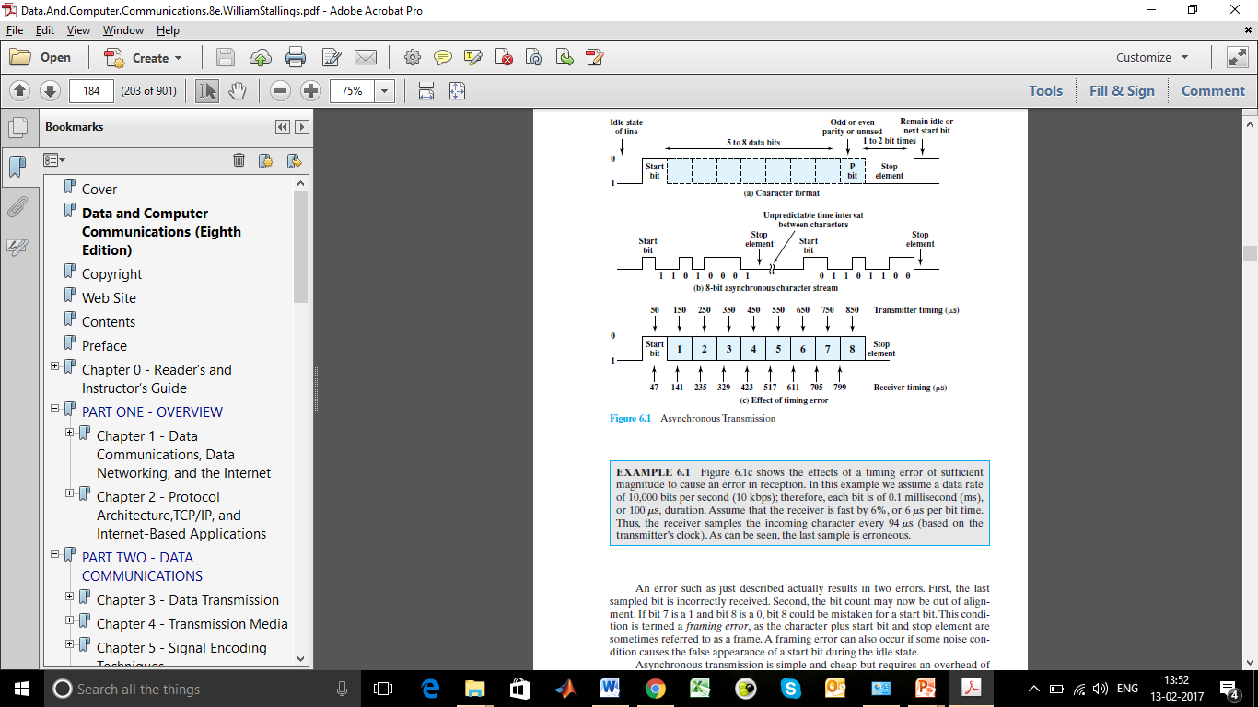

1. Define the following terms: (i) Absolute bandwidth; (ii) Bit error rate.

**Answer**: (i) The absolute bandwidth of a signal is the width of its spectrum. (Spectrum – range of frequencies contained by a signal).

(ii) Bit error rate (BER) is defined as the probability that a bit is received in error. (BER is also defined as the number of bit errors per unit time).

1. A receiver is known to have an effective noise temperature of 294K and a bandwidth of 10 MHz. What is the thermal noise level at the receiver output? [Boltzmann constant = 1.38 x 10-23]

**Answer**: Noise level N in decibel-watts = 10 log (k) + 10 log (T) + 10 log (B)

= – 228.6 + 10 log (294) + 10 log (10000000)

= – 228.6 + 24.7 + 70

= – 133.9 dbW

**Question 3**

Answer the following questions:

1. Explain briefly, with diagrams, the relation between bit rate and symbol (baud) rate. [2]

**Answer**: The data rate, or bit rate, is 1/Tb, where Tb = bit duration.

The baud rate, or modulation rate, is the rate at which signal elements are generated.

Consider, for example, Manchester encoding. The minimum size signal element is a pulse of one-half the duration of a bit interval, as shown in the diagram below. For a string of all binary zeroes or all binary ones, a continuous stream of such pulses is generated. Hence the maximum modulation rate for Manchester is 2/Tb.

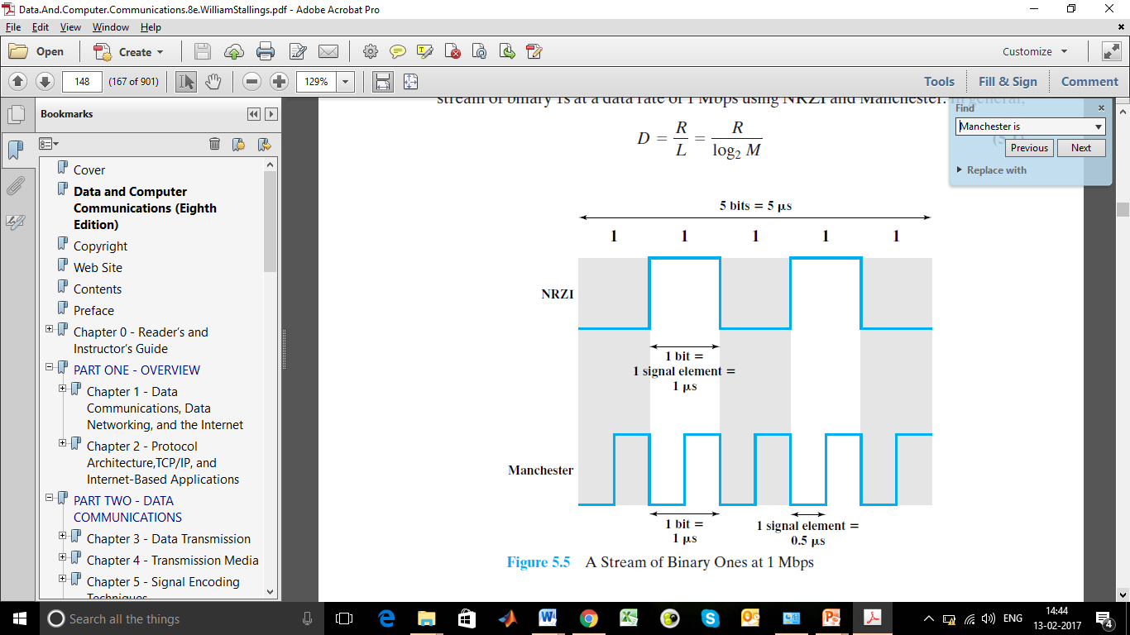

In general, D = R/L = R / log2 M, where:

D = modulation rate, baud

R = data rate, bps

M = number of different signal elements = 2L

L = number of bits per signal element

1. How does differential Manchester encoding differ from Manchester encoding? State with an example. [2]

**Answer**: In the Manchester code, there is a transition at the middle of each bit period. The mid bit transition serves as a clocking mechanism and also as data: a low-to-high transition represents a 1, and a high-to low transition represents a 0.

In differential Manchester, the mid bit transition is used only to provide clocking. The encoding of a 0 is represented by the presence of a transition at the beginning of a bit period, and a 1 is represented by the absence of a transition at the beginning of a bit period.

1. A typical telephone subscriber loop has a usable audio bandwidth of 0-8000 Hz. Voice samples for digital transmission using a modem are represented in 4 bits. What is the bit rate required for the digital transport of voice? What is the permissible S/N ratio to support this bit-rate? [2+2]

**Answer**: Here, log2 M = 4 since 4 bits are required for transmission.

C = 2 B log2 M = 2 x 8000 x 4 = 64000 bps

C = B log2 (1 + SNR) => 64000 = 8000 x log2 (1 + SNR) => log2 (1 + SNR) = 8 => 1 + SNR = 256 => SNR = 255

1. Suppose that an 11-Mbps 802.11b LAN is transmitting 64-byte frames back-to-back over a radio channel with a bit error rate of 10−7. How many frames per second will be damaged on average? [2]

**Answer**: Prob. of error per bit = 10-7, i.e., prob. of a bit arriving correctly = (1 – 10-7)

Prob. of a 64-byte frame arriving correctly = (1 – 10-7)64x8 = 0.9999488

Prob. of a frame being damaged = 1 – 0.9999488 = 5.12 x 10-5

Since data-rate is 11-Mbps, no. of frames transmitted per second = (11 x 106) / (64 x 8) = 21484.375 frames/sec

No. of damaged frames per second = no. of frames/sec x prob. of a frame being damaged

= 21484.375 x (5.12 x 10-5) = 1.0999 = 1.1 frames/sec (approx.)

**Question 4**

1. Consider a channel with a 1-MHz capacity and an SNR of 63. [1.5x2 = 3]
2. What is the upper limit to the data rate that the channel can carry?

**Answer**: C = B log2 (1 + SNR) = 106 x log2 (1 + 63) = 6 x 106 = 6 Mbps

1. The result of part (a) is the upper limit. However, as a practical matter, better error performance will be achieved at a lower data rate. Assume we choose a data rate of 2/3 the maximum theoretical limit. How many signal levels are needed to achieve this data rate?

**Answer**: C = 2B log2 M => (2/3) x (6x106) = 2 x (1x106) x log2 M => log2 M = 2 => M = 4

1. Answer the following questions with respect to video interlacing: [2x2 = 4]
2. State and illustrate the principle of video interlacing scanning.

**Answer**: Interlaced scan refers one method for "painting" a video image on an electronic display screen by scanning or displaying each line or row of pixels. This technique uses two fields to create a frame. One field contains all odd lines in the image; the other contains all even lines.

A PAL-based television set display, for example, scans 60 fields every second (30 odd and 30 even). The two sets of 30 fields work together to create a full frame every 1/30 of a second (or 30 frames per second), but with interlacing create a new half frame every 1/60 of a second (or 60 fields per second). To display interlaced video on progressive scan displays, playback applies de-interlacing to the video signal (which adds input lag).

1. Given that there are 483 lines in a TV screen, assume 60 scans per second, and width to height ratio of the TV screen as 4:3. What is the bandwidth of the video signal needed?

**Answer**: There are 483 rows and 483 x 3/4 columns. So the required bandwidth is:

483 x 483 x 3/4 x 60 bits/second = 10498005 bits/second.

1. Represent the signal 11001011101 using ASK, BFSK, and BPSK. [3]

**Answer**: The waveforms are given below:

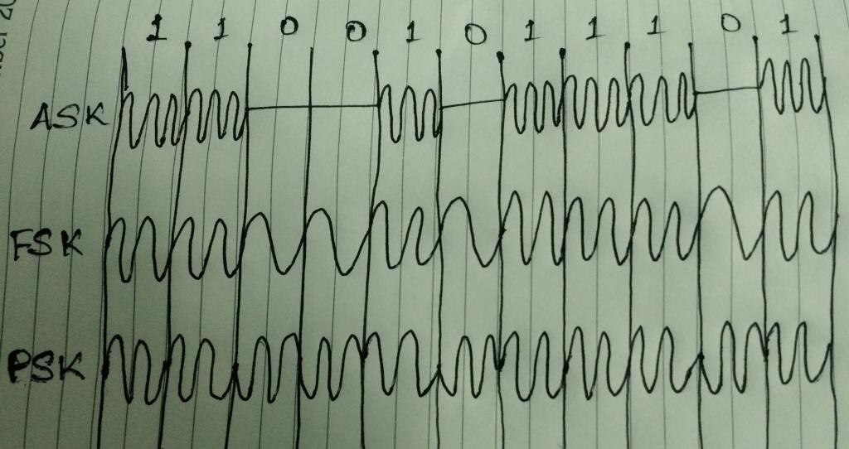

**Question 5**

1. Neatly draw the waveforms resulting from NRZ, NRZI, Manchester and AMI signaling for transmitting the bit stream "00110110". [1+1+1+1]

**Answer**: The waveforms are given below:

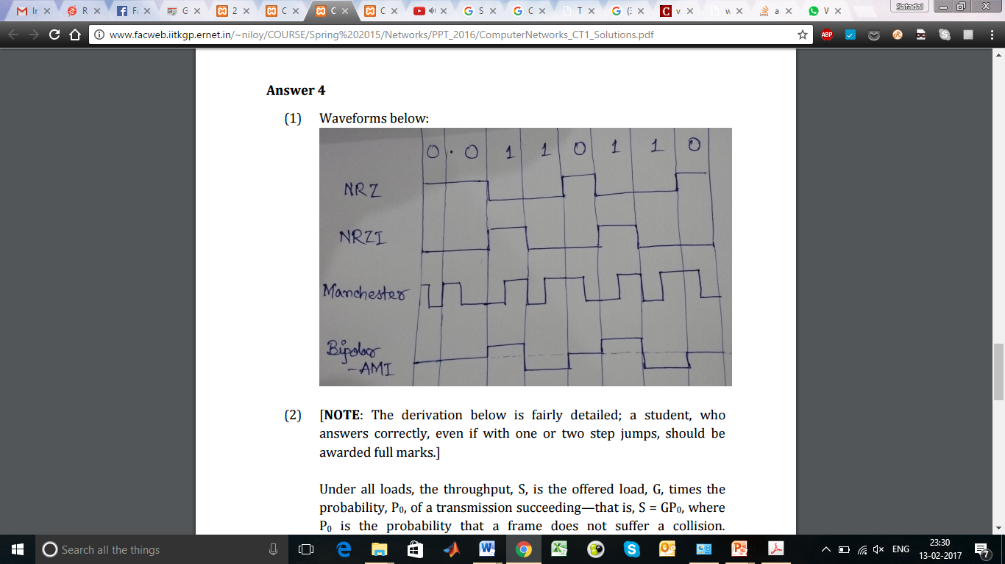

1. Suppose we want to transmit the message **1011 0010 0100 1011** and protect it from errors using the CRC-8 polynomial ${ x}^{8}+x^{2}+x^{1}+1$. [2+ (2+1)]
2. Use polynomial long division to determine the message that should be transmitted.

**Answer**: We take the message 1011 0010 0100 1011, append 8 zeros and divide by 1 0000 0111 (x8 + x2 + x1 + 1). The remainder is 1001 0011. We transmit the original message with this remainder appended, resulting in 1011 0010 0100 0011 1001 0011.

1. Suppose the leftmost bit of the message is inverted due to noise on the transmission link. What is the result of the receiver’s CRC calculation? How does the receiver know that an error has occurred?

**Answer**: Inverting the first bit gives 0011 0010 0100 1011 1001 0011. Dividing by 1 0000 0111 (x8 + x2 + x1 + 1) gives a remainder of 1011 0110. A remainder indicates error.

1. State two types of noise encountered in communication. [1]

**Answer**: Types of noise: Thermal noise or white noise, Shot noise, Transit time noise

(Any 2 of thermal noise, intermodulation noise, crosstalk, and impulse noise are also acceptable answers).